NEU271 Lab 3:
Using Muse to Collect EEG Data

PART I – Electrode placement
Before we record EEG, fit the 10-20 system to your partner’s head. Everyone should have a chance to do this, so take turns with your partner.
First find the 4 landmark points on your partner and mark the skin with the oil pencil OR small dot of paper tape or a larger piece of paper tape with an oil pencil dot if it’s on hair.
- Preauricular points: The opening of your ear canal is protected with protruding cartilage called the tragus (trivia fact!). The indentation right in front of the tragus (toward your nose) is a preauricular point. If you can’t find it, put your finger on your jaw and open and close your mouth. This should accentuate the preauricular point.
- Nasion: The indentation between your forehead and nose. It’s the small dip at the bridge of your nose between your eyes.
- Inion: The ridge/knob at the back of your head. Run your finger up the back of your neck to your skull. You should feel a depression, and the small bump of the inion protruding out above. The inion can be hard to find on some people! Try nodding your head slowly up and down to find it. If you can’t find the inion, use a point at the back of the head at the same vertical level as the preauricular points.

- Using the tape measure, what is the distance (over the top of the head) between the preauricular points?
X = cm

- What is the distance (over the top of the head) between the inion and nasion?
Y = cm

The 4 electrodes of the Muse headband are labeled: TP9, AF7, AF8, TP10.
- Which two are on the metal band? Which two are on the rubber ear pieces?

- Which two are on the left? What about their names tells you this?

- Calculate the distance between the nasion (Nz) and Fpz (same as inion and Oz), which is 10% of the nasion-to-inion distance (X from step #1). Then measure that distance from nasion to inion and mark that location of Fpz and Oz on your partner’s head. (See Fig. 1)

X * 10% = cm
- Calculate the distance between the left preauricular point and T9 (same as right preauricular and T8), which is 10% of the left-to-right preauricular distance distance (Y from step #2). Then measure that distance from left and right preauricular points and mark that location of T8 and T9 on your partner’s head.

Y * 10% = cm
- Measure around your partner’s head in a circle connecting Fpz, T8, Oz, and T7 (Measuring tape like a crown.) What is the circumference? This will be the inner ring on Figure 1.

Circ = cm
- Now let’s locate the AF electrode positions along that circumference. Calculate the distance between FPz and AF7 (same as between FPz and AF8) which is 10% of the circumference (Circ from step #7). Mark AF7 and AF8 on your partner’s head.

Circ * 10% = cm

- Now let’s locate the TP row along the the circumference. Calculate the distance between T7 and TP7 (same as between T8 and TP8), which is 5% of the circumference from step 7. Mark on your partner’s head.

Circ * 5% = cm
- What is the distance (over the top of the head) between TP7 and TP8?

Z = cm
- Calculate the distance between TP7 and TP9 (same as between TP8 and TP10), which is 10% of the TP7 to TP8 distance (Z from step #10). Then measure that distance down from TP7 to TP9 and from TP8 to TP10, and mark TP9 and TP10 on your partner’s head.

Z * 10% = cm

PART II

Use the attached instructions (and troubleshooting tips!) to put on the Muse headband.
Remember, please only put on the Muse headband if you’re comfortable doing so. You do not have to use the headband if you’re uncomfortable. Or if having the headband on your head becomes uncomfortable, you may stop at any time!

- Are the electrodes lined up with the MCN locations you calculated? Which ones are close or far? How close or far are each of them (in cm)?

- Describe your experience putting on the headband and getting a good fit. Did it work perfectly the first time? If not, what trouble-shooting steps did you have to take either before you put it on, or on later attempts.

- Let’s be honest…the first part was a huge pain! How do many researchers use EEG and the 10-20 or MCN WITHOUT having to calculate every single electrode position individually?

PART III

Let’s look at what different kinds of artifacts. Go to the “Raw” data-viewing mode with one trace per electrode.
For each of the following potential artifact sources, explore the relationship between the source and the resulting artifact in the raw traces. Write 3-4 sentences on each. For example
- Can you generate an artifact? If so, what does the artifact look like? As you get farther down the list, compare to other artifact sources.
- Does it affect some electrodes more than others? If so, which ones and why?
- Do changes in the source affect the artifact? (For example, does moving faster or making a stronger motion change the trace?)

- Blinking

- Eye movement (right/left, up/down)

- Head motion

- Jaw clench

- Chewing

- Foot tapping

PART IV
Let’s look at how head motion is measured. Go to the “Accelerometer and Gyroscope” data-viewing mode with the 3 accelerometer measurements on the top graph, and the 3 gyroscope measurements on the bottom graph.

- What direction (or type) of head movement corresponds to the X, Y, and Z directions for the Muse headband?

PART V

Now, let’s collect some data that we’ll analyze next class! Follow the attached Muse instructions to record the data.

Record data for each of the following actions. Don’t forget to put notes about which action/state is represented by the recording in the email subject line or body. For each action/state, write the frequency band you would expect to have increased power by the action/state.
- Awake and relaxed, eyes closed.

- Awake and relaxed, eyes open

- Choose one. Don’t tell participant which one until right before you start recording
  - (Eyes open). Counting backward from 200 by 7s (i.e., “200, 193, …”) in their head (not out loud).
  - (Eyes open.) Partner names a letter (choose F, S, P, or B), participant names words that start with that letter in their head (not out loud). Remember, give the letter RIGHT before starting to record.
  - (Eyes open.) Partner names category of things, and participant names things in that category in their head (not out loud). Give the category RIGHT before starting to record.

- (Eyes open.) Imagine reciting the words to the pledge of allegiance, the words to a song you know well, or a poem, etc.

- (Eyes open.) Listen closely to your partner read something out loud.

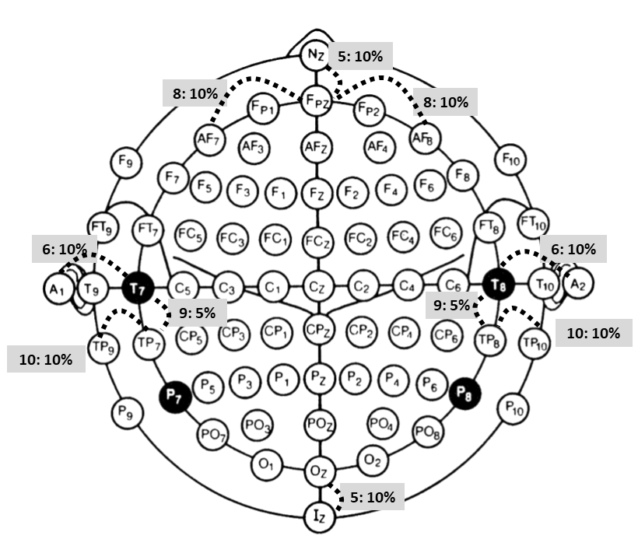
Figure 1: Modified Combinatorial Nomenclature for EEG electrode placement. Dotted lines indicate measurements made in the lab. In the grey boxes, the step number in the above text, followed by the size/percentage of the measurement associated.

